158.337

GROUP PROJECT

GROUP 35

PART B

Queries (SQL/LINQ), Triggers, Procedures, Functions (PL/SQL) & MongoDB (NoSQL)

Written by:
Mohit Negi 23021700
Zaahid Benjamin 23013649
John Lavack 20001249

Contents
Section A 3
Question Aa) 3
Question Ab) 5
Question Ac) 6
Question Ad) 7
Question Ae) 8
Question Af) 9
Question Ag) 11
Question Ah) 12
Section B 13
Question Ba) 13
Question Bb) 29
Question Bc) 31
Question Bd) 33
Question Be) 38
Question Bf) 40
Section C 42
Question Ca) 42
Question Cb) 44
Question Cc) 45
Question Cd) 46
Question Ce) 47
Section D 48
Question Da) 48
Question Db) 50
Question Dc) 52
Appendix A: Marking Sheet: 53

Section A (SQL Queries)
Outputs are provided as both excel exports and snips, the latter to show that the output was not manufactured outside Oracle. Note outputs may vary from what is presented here if code is run in current database, as test records were added during section B.

Question Aa)
Write a query that lists both customer and author details (only their ids, first and
last names). Provide suitable headings for the merged list:

Code:
SELECT
TO_CHAR(Cust_Num) AS "ID" ,
Cust_FName || ' ' || Cust_LName AS "Full Name"
FROM CUSTOMER
UNION
SELECT
Author_ID AS "ID",
Author_FName || ' ' || Author_LName AS "Full Name"
FROM AUTHOR
;

Output:
ID | Full Name
1001 | BONITA MORALES
1002 | RYAN THOMPSON
1003 | LEILA SMITH
1004 | THOMAS PIERSON
1005 | CINDY GIRARD
1006 | MESHIA CRUZ
1007 | TAMMY GIANA
1008 | KENNETH JONES
1009 | JORGE PEREZ
1010 | JAKE LUCAS
1011 | REESE MCGOVERN
1012 | WILLIAM MCKENZIE
1013 | NICHOLAS NGUYEN
1014 | JASMINE LEE
1015 | STEVE SCHELL
1016 | MICHELL DAUM
1017 | BECCA NELSON
1018 | GREG MONTIASA
1019 | JENNIFER SMITH
1020 | KENNETH FALAH
A100 | JAMES AUSTIN
A105 | JUAN ADAMS
B100 | JACK BAKER
D200 | Aeneas Dardania
F100 | OSCAR FIELDS
I200 | Odysseus Ithica
J100 | JANICE JONES
K100 | TAMARA KZOCHSKY
M100 | SHEILA MARTINEZ
M200 | Agamemnon Mycenae
P100 | LISA PORTER
P105 | TINA PETERSON
R100 | ROBERT ROBINSON
S100 | SAM SMITH
W100 | WILLIAM WHITE
W105 | LISA WHITE
W110 | ANTHONY WILKINSON
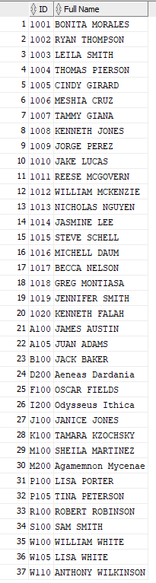

Question Ab)
Write a query that will list the books with the price difference (between retail and
cost) of $20 or more. Display your results in the decreasing order of the price
difference

Code:
SELECT
Book_Title AS "Book Title",
Book_Retail - Book_Cost AS "Price Difference"
FROM BOOK
WHERE
Book_Retail - Book_Cost >= 20
ORDER BY "Price Difference" DESC
;

Output:

Book Title | Price Difference
PAINLESS CHILD-REARING | 41.95
HOLY GRAIL OF ORACLE | 28.7
DATABASE IMPLEMENTATION | 24.55
BUILDING A CAR WITH TOOTHPICKS | 22.15

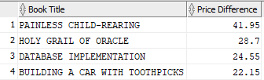

Question Ac)
Write a query that will list books that have retail price of $35 or less and
were published in any of the years 1999 or 2001. Display the year of publication
values under the column titled as Publication Year. Show the query results in the
increasing order of the publication year and decreasing retail price.

Code:
SELECT
Book_Title AS "Book Title",
Book_Retail AS "Retail Price",
Book_Pubdate AS "Publication Year"
FROM BOOK
WHERE (
Book_Retail <= 35
AND (
TO_CHAR(Book_Pubdate, 'YYYY') = '1999'
OR TO_CHAR(Book_Pubdate, 'YYYY') = '2001'
)
)
ORDER BY
"Publication Year" ASC,
"Retail Price" DESC
;

Output:
Book Title | Retail Price | Publication Year
HOW TO MANAGE THE MANAGER | 31.95 | 9/05/1999
BODYBUILD IN 10 MINUTES A DAY | 30.95 | 21/01/2001
HANDCRANKED COMPUTERS | 25 | 21/01/2001
BIG BEAR AND LITTLE DOVE | 8.95 | 8/11/2001
REVENGE OF MICKEY | 22 | 14/12/2001

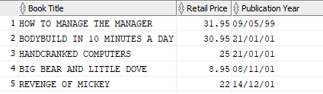

Question Ad)
Write a query that will list publishers (with details such as name) and total
number of books published by them. Include only those publishers that have 2
or more books published and display your output in the decreasing order of
total number of publications

Code:
SELECT
PUBLISHER.Pub_Name AS "Publisher Name",
COUNT(BOOK.Pub_ID) AS "Total Publications"
FROM BOOK
INNER JOIN
Publisher
ON
PUBLISHER.Pub_ID = BOOK.Pub_ID
GROUP BY
PUBLISHER.Pub_Name
HAVING COUNT(BOOK.Pub_ID) >1
ORDER BY
"Total Publications" DESC
;

Output:
Publisher Name | Total Publications
READING MATERIALS INC. | 4
PRINTING IS US | 4
REED-N-RITE | 3
AMERICAN PUBLISHING | 3
PUBLISH OUR WAY | 2

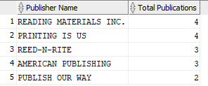

Question Ae)
Write a query to list books that have multiple authors. Also, display the number of
authors who wrote the book.

Code:
SELECT
BOOK.Book_Title AS "Book Title",
COUNT(BOOKAUTHOR.Book_ISBN) AS "Total Authors"
FROM BOOKAUTHOR
INNER JOIN
BOOK
ON
BOOK.Book_ISBN = BOOKAUTHOR.Book_ISBN
GROUP BY
BOOK.Book_Title
HAVING COUNT(BOOKAUTHOR.Book_ISBN) >1
ORDER BY
"Total Authors"
DESC
;

Output:
Book Title | Total Authors
DATABASE IMPLEMENTATION | 3
PAINLESS CHILD-REARING | 3
HANDCRANKED COMPUTERS | 2
BODYBUILD IN 10 MINUTES A DAY | 2

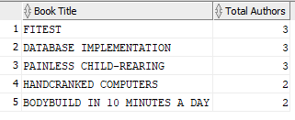

Question Af)
Write a query that will list books from the ‘computer’ category along with other
details such as author(s), publisher, etc. List the book authors in a single row and
the query should be able to accommodate all the casing-variations of the category
values in the database.

Code:

Note, that because the question requirements were somewhat vague and only stipulated details such as authors, publisher, book title and category, there are shown in the code. The code provided is easily editable to include any other fields. Instructions to do so are shown as comments in the code.
WITH A AS (
SELECT
BOOK.*, --allows any book attribute to be selected
BOOKAUTHOR.*,
AUTHOR.Author_Fname || ' ' || Author.Author_LName AS "Author",
PUBLISHER.Pub_name
FROM BOOK
JOIN BOOKAUTHOR ON BOOK.Book_isbn = BOOKAUTHOR.book_isbn
JOIN AUTHOR ON BOOKAUTHOR.Author_id = AUTHOR.author_id
JOIN PUBLISHER ON BOOK.pub_id = PUBLISHER.pub_id
WHERE Book_Category = 'COMPUTER'
)

SELECT --specifically select and alias any book table value you want
Book_title AS "Title",
book_category AS "Category" ,
pub_name AS "Publisher",
LISTAGG("Author", ', ') AS "Authors"
FROM A
--include all selected book attributes in the group by statement to show them in output
GROUP BY Book_title, book_category, pub_name
;

Output:
Book Title | Category | Publisher | Authors
HOLY GRAIL OF ORACLE | COMPUTER | AMERICAN PUBLISHING | JAMES AUSTIN
DATABASE IMPLEMENTATION | COMPUTER | AMERICAN PUBLISHING | JAMES AUSTIN, JUAN ADAMS, TINA PETERSON
E-BUSINESS THE EASY WAY | COMPUTER | PUBLISH OUR WAY | JANICE JONES
HANDCRANKED COMPUTERS | COMPUTER | AMERICAN PUBLISHING | WILLIAM WHITE, LISA WHITE

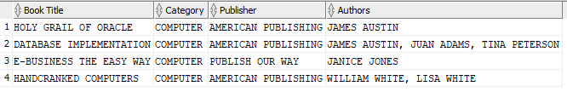

Question Ag)
Write a query that will list the customer who has ordered the greatest number of
items (two copies of the same book will be counted as two items) to date. If there
is more than one customer, then your query should list all those customers.

Code:
SELECT
Customer.Cust_Num AS "Customer Number",
Customer.Cust_FName || ' ' || Customer.Cust_LName AS "Customer Name",
COUNT(BookOrderItem.BO_OrderNum) AS "Total Items Ordered"
FROM CUSTOMER
INNER JOIN
BOOKORDER
ON
CUSTOMER.Cust_Num = BookOrder.Cust_Num
INNER JOIN
BOOKORDERITEM
ON
BOOKORDER.BO_OrderNum = BOOKORDERITEM.BO_OrderNum
GROUP BY
CUSTOMER.Cust_Num, CUSTOMER.Cust_FName, CUSTOMER.Cust_LName
HAVING COUNT(BOOKORDERITEM.BO_OrderNum) = (
SELECT MAX(ItemCount)
FROM (SELECT
COUNT(BOOKORDERITEM.BO_OrderNum) AS ItemCount
FROM BOOKORDERITEM
GROUP BY BOOKORDERITEM.BO_OrderNum
)
)
;

Output:
Customer Number | Customer Name | Total Items Ordered
1017 | BECCA NELSON | 4

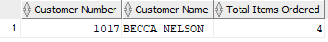

Question Ah)
Write a query that will display the customer that referred the greatest number of
customers. Again, like g) there can be more than one customer.

Code:
SELECT
C.Cust_referred_by AS "Customer Number",
CUSTOMER.Cust_FName || ' ' || CUSTOMER.Cust_LName AS "Customer Name",
COUNT(*) AS "Total Referrals"
FROM CUSTOMER
LEFT JOIN CUSTOMER C ON CUSTOMER.Cust_num = C.Cust_referred_by
GROUP BY C.Cust_referred_by, CUSTOMER.Cust_FName, CUSTOMER.Cust_LName
HAVING COUNT(*) = (
SELECT MAX(ReferralCount)
FROM (
SELECT
COUNT(*) AS ReferralCount
FROM CUSTOMER
WHERE
Cust_Referred_by IS NOT NULL
GROUP BY
Cust_Referred_by
)
)
;

Output:

Customer Number | Customer Name | Total Referrals
1003 | LEILA SMITH | 3

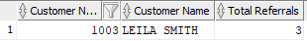

Section B (PL SQL)

Question Ba)
Think of some useful business rule or situation (based on the provided database) where it would be appropriate for your trigger to fire…

The business process targeted is sales, which has a direct link to inventory management.
The trigger created does f things when a new book order item is created.
- When a sale is added as an order item the cost is calculated and added to the total order.
- The number of items added are reduced from the book’s stock level.
- If the stock level goes below the minimum stock level, a flag to reorder is raised by setting the ‘reorder’ value to 1. A system message is printed.
- If the order would put the stock below 0, then an error is thrown indicating there is not enough stock. This was decided as opposed to triggering a backorder process, which would be a separate business process requiring a customer decision point; to accept longer delivery times or not.
- If the order total in the BOOKORDER table becomes over $200 a 10% discount is applied. The discount if applied only once for the first time this condition is met, else the discount could become very large. This is achieved, by requiring the ‘discount’ flag to be 0 in the BOOKORDER table. If this is not true, then the discount is not applied.

In order to fulfil the trigger several new columns have been added to the existing BOOK and BOOKORDER tables.
To BOOK:
- BOOK_STOCK defaulting to 50 for the testing of the trigger. In a business setting this would be updated when inventory was received.
- BOOK_STOCK_MIN defaulting to 15 for testing the trigger. Likewise, in a business setting this would be identified over time and set differently for each item.
- BOOK_REORDER default to 0. A Boolean flag that identifies if a book needs reordering. The following business process to identify the amount worth reordering and lodging the reorder is not covered.
To BOOKORDER:
- BO_COST added to hold the order total cost calculated as an incremental sum with each item added to the order.
- BO_DISCOUNT as a Boolean flag default to 0. Identified is the discount has been applied to the order and control the logic to not add further, unprofitable discounts.

Code:
/*ALTER TABLE CODE FOR TRIGGER*/
ALTER TABLE BOOKORDER
ADD BO_COST NUMBER(7,2)
DEFAULT 0
;

ALTER TABLE BOOKORDER
ADD BO_DISCOUNT NUMBER(1)
DEFAULT 0
;

ALTER TABLE BOOKORDER
ADD CONSTRAINT DISCOUNT_FLAG CHECK (bo_discount IN (0, 1))
;

ALTER TABLE BOOK
ADD BOOK_STOCK NUMBER(4)
DEFAULT 50
;

ALTER TABLE BOOK
ADD BOOK_STOCK_MIN NUMBER(2)
DEFAULT 15
;

ALTER TABLE BOOK
ADD BOOK_REORDER NUMBER(1)
DEFAULT 0
;

ALTER TABLE BOOK
ADD CONSTRAINT REORDER_FLAG CHECK (book_reorder IN (0, 1))
;

------------------------------------------------------------------------------

/*TRIGGER CODE*/
CREATE OR REPLACE TRIGGER total_order_trg_2
AFTER INSERT ON BOOKORDERITEM

FOR EACH ROW

DECLARE
total NUMBER(7,2) := 0;
ordernum NUMBER(4);
qty NUMBER(2) := 0;
stockredux NUMBER(2) :=0;
stockmin NUMBER(2) :=0;
stock_level_error EXCEPTION;
discount NUMBER(1) :=0;

BEGIN

--1)get bo_order
SELECT bo_ordernum INTO ordernum
FROM BOOKORDER
WHERE BOOKORDER.bo_ordernum = :new.bo_ordernum;

--2) update bookorder total cost
SELECT
:new.boi_qty * book_retail INTO total
FROM BOOK
WHERE book_isbn = :new.book_isbn;

--3) update bookorder cost
UPDATE BOOKORDER
SET BOOKORDER.bo_cost = BOOKORDER.bo_cost + total
WHERE BOOKORDER.bo_ordernum = :new.bo_ordernum;

--4) reduce book stock
qty := :new.boi_qty;

SELECT
BOOK.book_stock_min INTO stockmin
FROM BOOK
WHERE BOOK.book_isbn = :new.book_isbn;

SELECT
BOOK.book_stock - qty INTO stockredux
FROM BOOK
WHERE BOOK.book_isbn = :new.book_isbn;

UPDATE BOOK
SET BOOK.book_stock = BOOK.book_stock - qty
WHERE BOOK.book_isbn = :new.book_isbn;

/*--DEBUG code
DBMS_OUTPUT.PUT_LINE(ordernum);
DBMS_OUTPUT.PUT_LINE(qty);
DBMS_OUTPUT.PUT_LINE(stockredux);
DBMS_OUTPUT.PUT_LINE(total);
*/

--5) check stock level
IF stockredux < 0
THEN
DBMS_OUTPUT.PUT_LINE ('NOT ENOUGH STOCK');
RAISE stock_level_error;

ELSE IF stockredux < stockmin
THEN
DBMS_OUTPUT.PUT_LINE ('reorder ticket raised');
UPDATE BOOK
SET BOOK.book_reorder = 1
WHERE BOOK.book_isbn = :new.book_isbn;
END IF;
END IF;

--6) Check and apply 10% discount to order over $200
SELECT
bo_cost INTO total
FROM BOOKORDER
WHERE BOOKORDER.bo_ordernum = :new.bo_ordernum;

SELECT
BO_discount INTO discount
FROM BOOKORDER
WHERE BOOKORDER.bo_ordernum = :new.bo_ordernum;

IF total > 200 AND discount = 0
THEN total := total * 0.9;
UPDATE BOOKORDER
SET BOOKORDER.bo_cost = total,
BOOKORDER.bo_discount = 1
WHERE BOOKORDER.bo_ordernum = :new.bo_ordernum;
DBMS_OUTPUT.PUT_LINE('Discount Applied, purchase reduced to');
DBMS_OUTPUT.PUT_LINE(total);

ELSE IF total > 200 AND discount = 1
THEN
UPDATE BOOKORDER
SET BOOKORDER.bo_cost = total
WHERE BOOKORDER.bo_ordernum = :new.bo_ordernum;
END IF;
END IF;

EXCEPTION
WHEN stock_level_error
THEN raise_application_error(-20002, 'Not Enough Stock for sale');

END;
/
------------------------------------------------------------------------------

Test:
/* TEST CODE */
INSERT INTO BOOKORDERITEM
VALUES (9999, 1, '0000000001', 5); --now have 45 stock, not discounted

INSERT INTO BOOKORDERITEM
VALUES (9999, 2, '0000000001', 15); -- now have 30 stock, discounted

INSERT INTO BOOKORDERITEM
VALUES (9999, 3, '0000000001', 10); -- now have 20 stock, not discounted

INSERT INTO BOOKORDERITEM
VALUES (9999, 4, '0000000001', 10); --trigger reorder, now have 10 stock, not discounted

INSERT INTO BOOKORDERITEM
VALUES (9999, 5, '0000000001', 10); --now have 0 stock, not discounted

INSERT INTO BOOKORDERITEM
VALUES (9999, 6, '0000000001', 10); --trigger out of stock exception

INSERT INTO BOOKORDERITEM
VALUES (9999, 7, '0401140733', 5); --add another book to the order, no discount

INSERT INTO BOOKORDERITEM
VALUES (1000, 9, '3437212490', 2); -- order with no discount, stock reduced to 48

INSERT INTO BOOKORDERITEM
VALUES (1000, 10, '3437212490', 50); -- stock would go below 0, trigger out of stock exception
/*--------------------------------------------------------------------------*/

Output:
Before the trigger:
BOOK: all stock levels at 50, all stock minimums at 15 and all reorders set to 0.
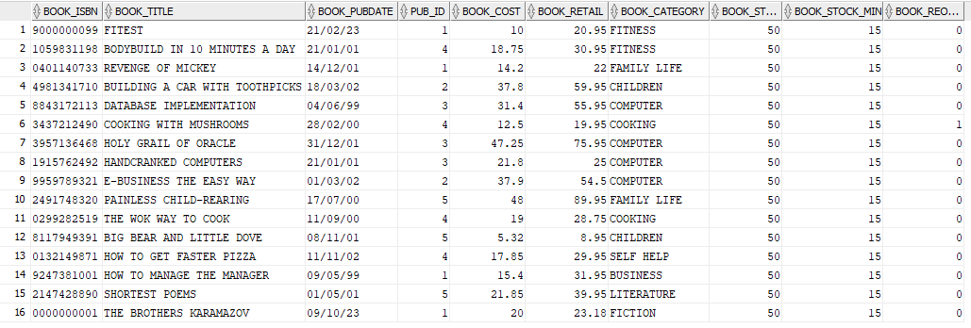

BOOKORDER: all costs set to 0, all discount flags at 0.
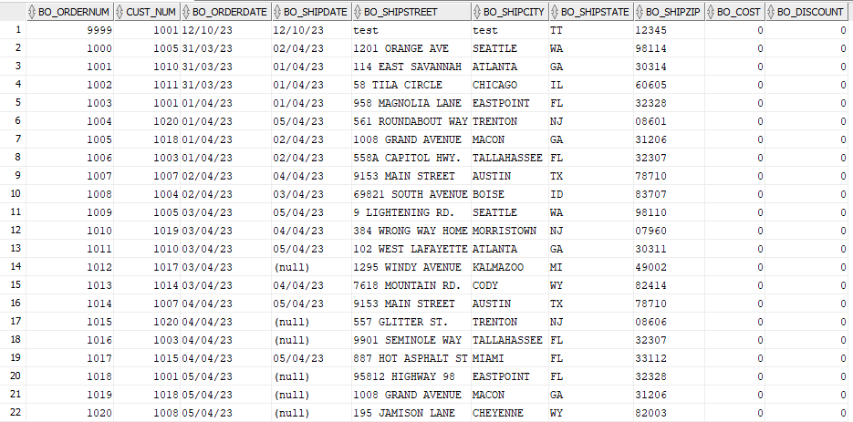

BOOKORDERITEM has no record for order number 9999
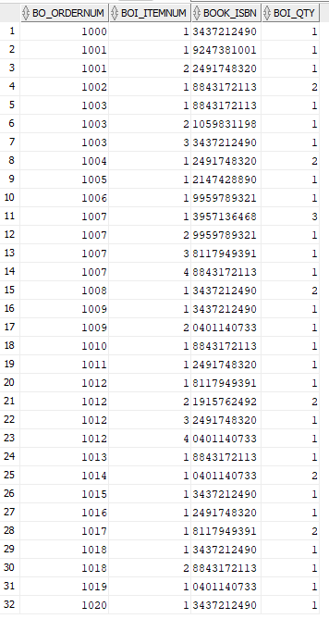

After the trigger:
First trigger. BOOKORDERITEM has record; 9999, 1 with 5 items. BOOKORDER has increased to $115.9 and BOOK stock for ‘The Brothers Karamazov’ has reduced to 45.
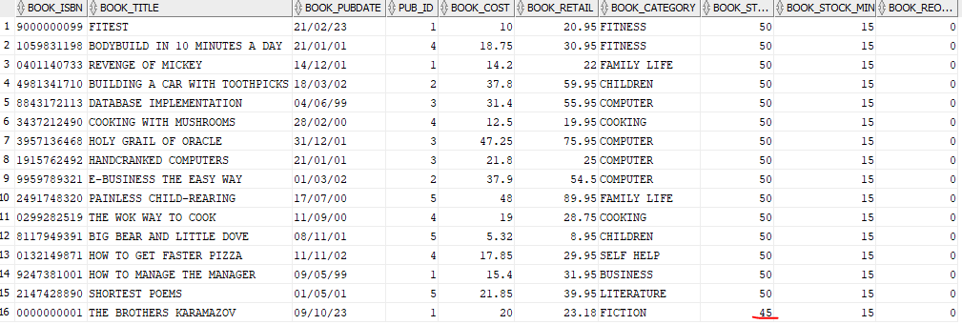
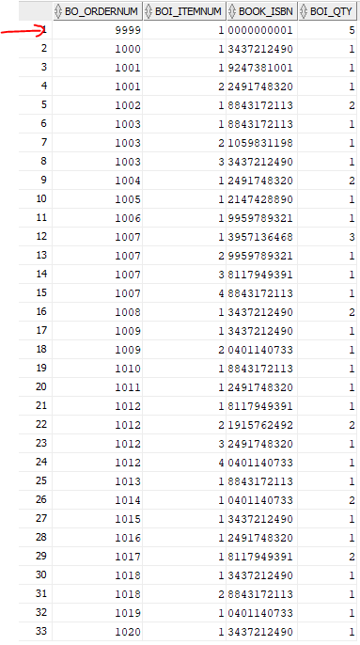
BOOKORDER ITEM: BOOK:

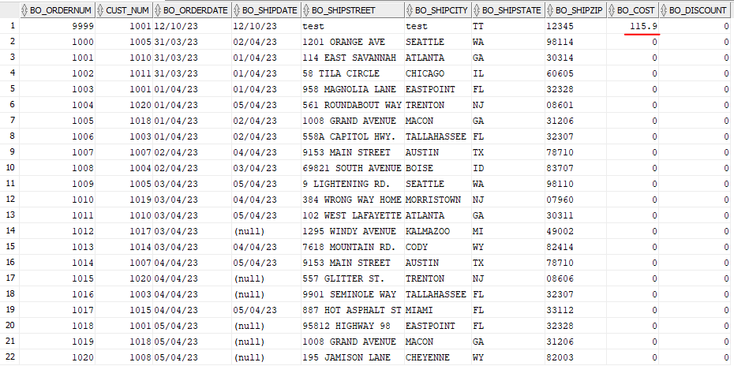
BOOKORDER:

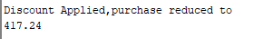
Second trigger. BOOKORDERITEM has record; 9999, 2 with 15 items. BOOKORDER increases, discount is activated, cost has increased to $417.24 and BOOK stock for ‘The Brothers Karamazov’ has reduced to 30. System message displayed:
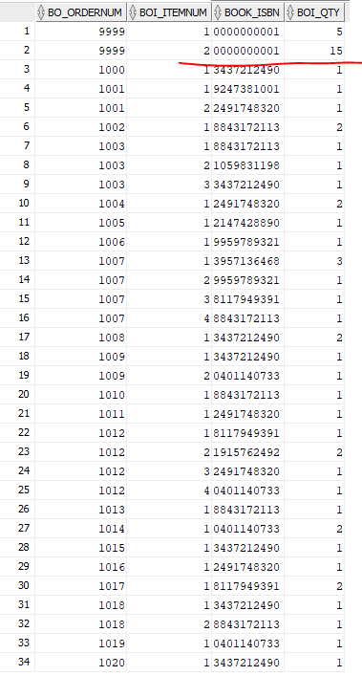
BOOKORDER ITEM: BOOK:
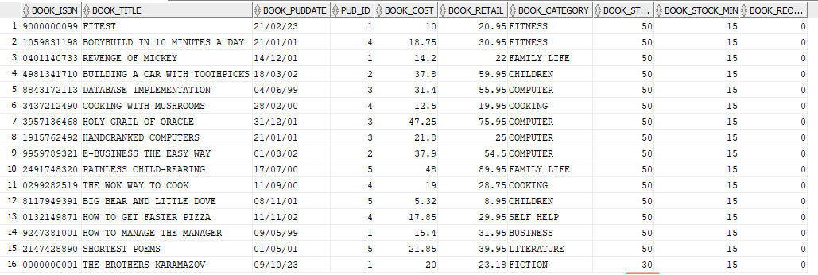

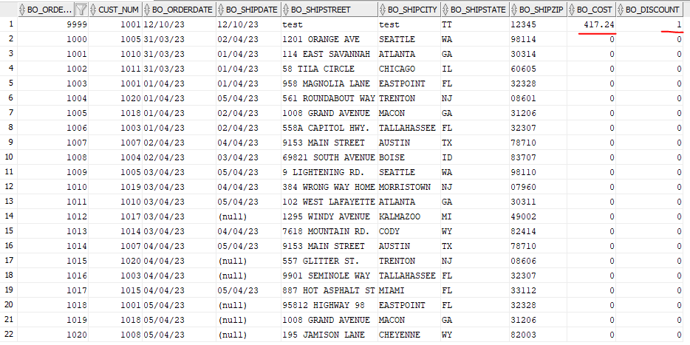
BOOKORDER:

Third trigger. BOOKORDERITEM has record; 9999, 3 with 10 items. BOOKORDER increases, to $649.04, no discount and BOOK stock for ‘The Brothers Karamazov’ has reduced to 20.
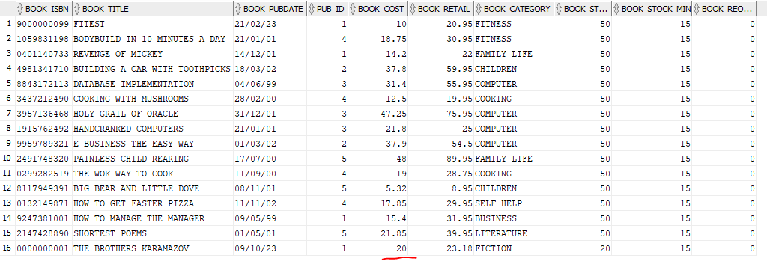
BOOKORDER ITEM: BOOK:
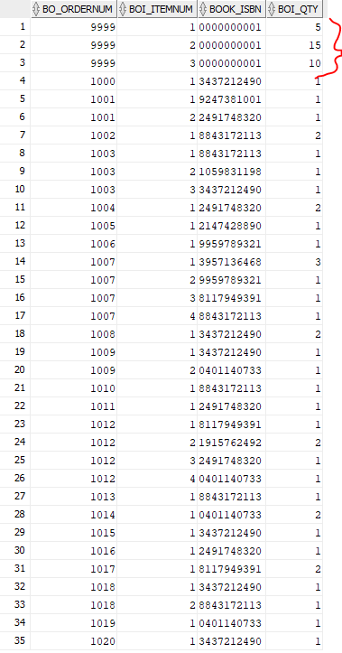

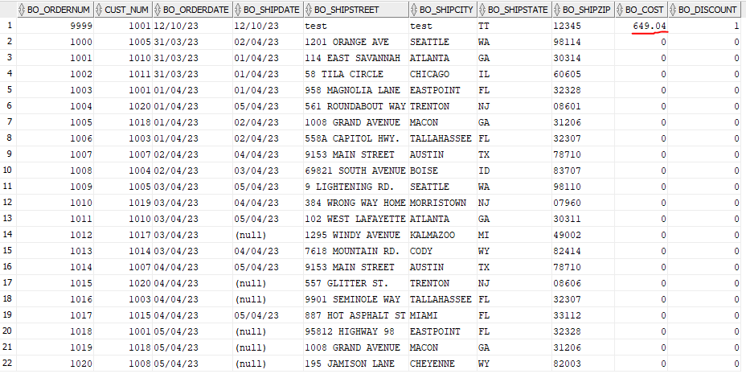
BOOKORDER:

Fourth trigger. BOOKORDERITEM has record; 9999, 4 with 10 items. BOOKORDER increases, to $880.84 and BOOK stock for ‘The Brothers Karamazov’ has reduced to 10, reorder set to 1, system output:
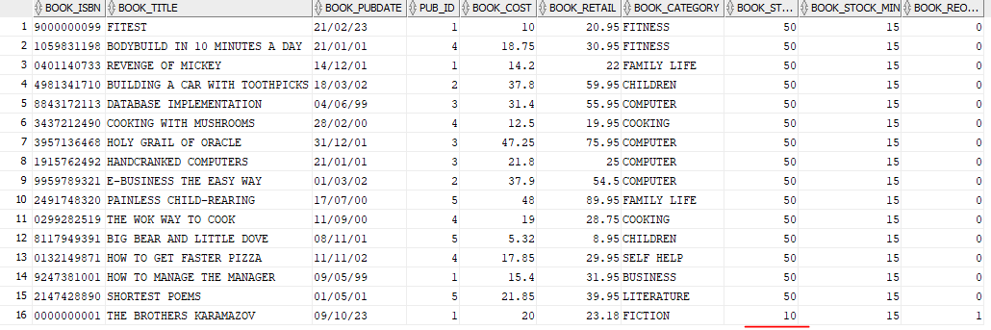
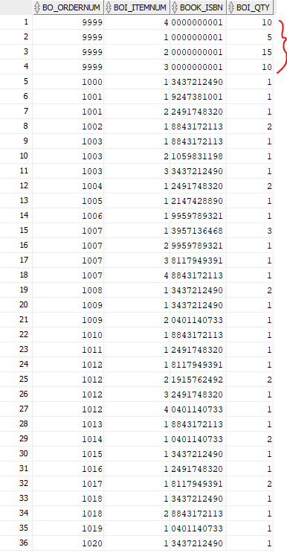
BOOKORDER ITEM: BOOK:

BOOKORDER:
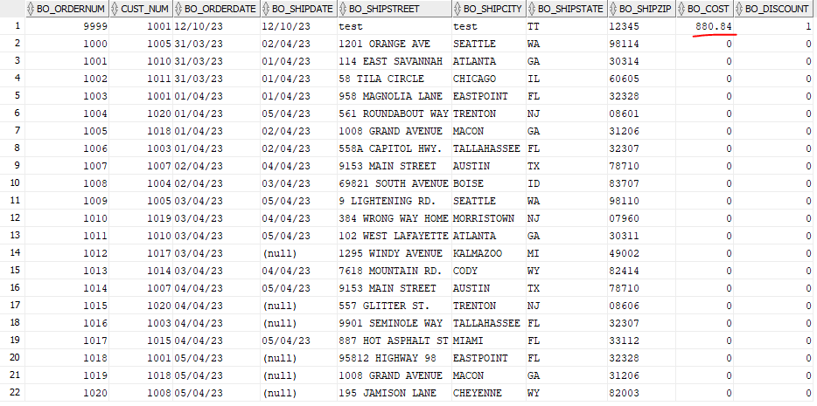

Fifth trigger. BOOKORDERITEM has record; 9999, 5 with 10 items. BOOKORDER increases, to $1112.64 and BOOK stock for ‘The Brothers Karamazov’ has reduced to 0.
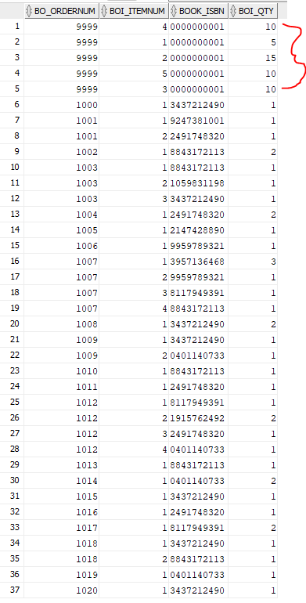
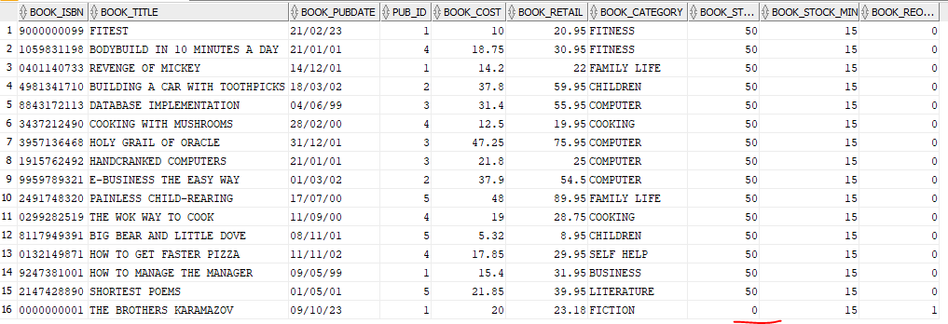
BOOKORDER ITEM: BOOK:

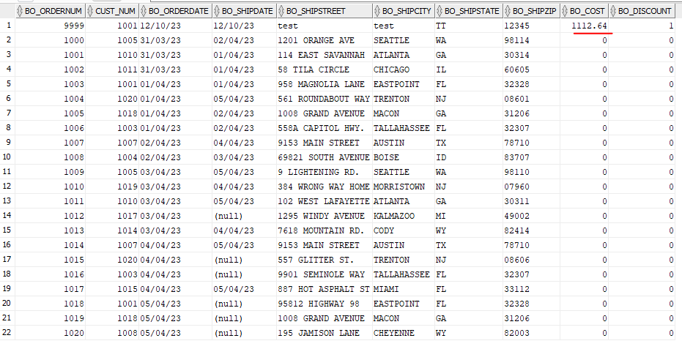
BOOKORDER:

Sixth trigger. BOOKORDERITEM has record; 9999, 6 with 10 items not created. System throws exception message.
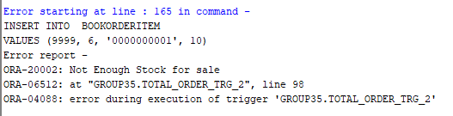

Seventh trigger. BOOKORDERITEM has record; 9999, 7 with 5 items of another book. BOOKORDER increases, to $1222.64 and BOOK stock for ‘Revenge of Mickey’ has reduced to 45.
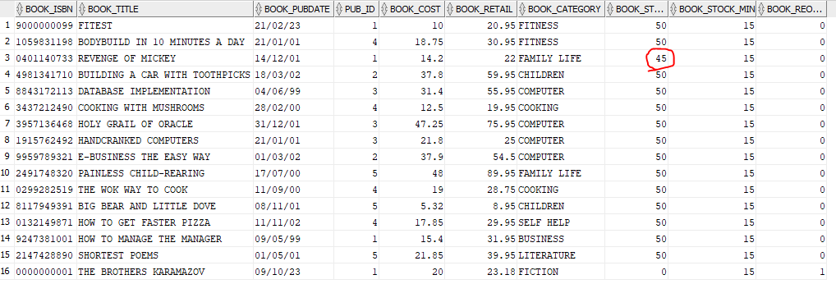
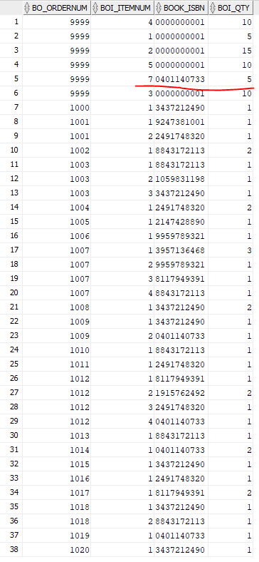
BOOKORDER ITEM: BOOK:

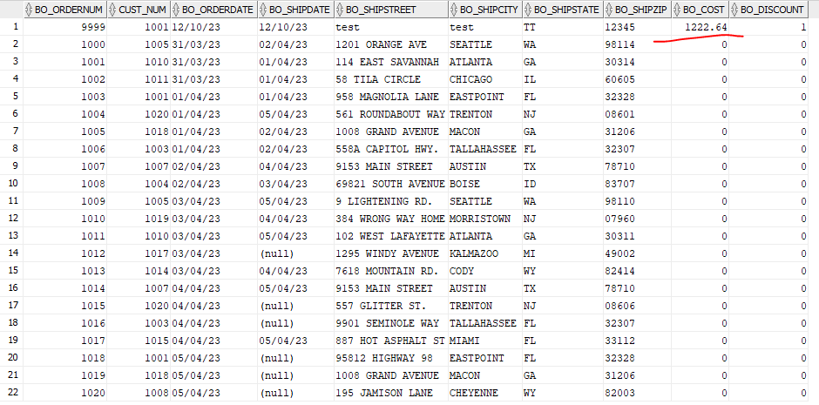
BOOKORDER:

Eighth trigger. BOOKORDERITEM has record; 1000, 9 with 2 added. BOOKORDER increases, to $39.9 and BOOK stock for ‘Cooking with mushrooms’ has reduced to 48.
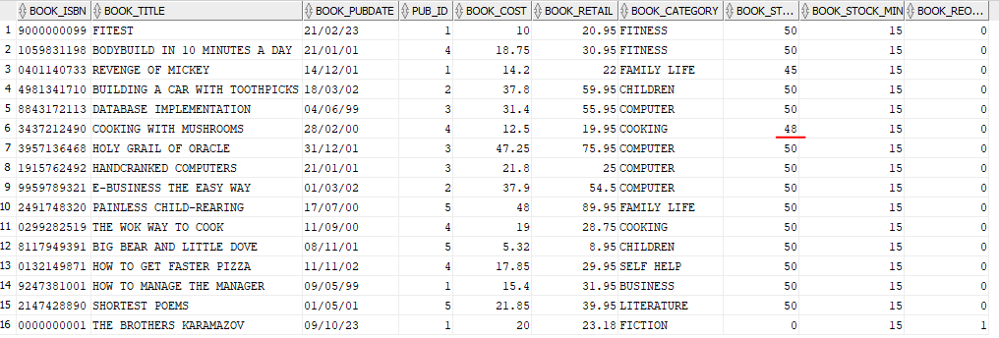
BOOKORDER ITEM: BOOK:
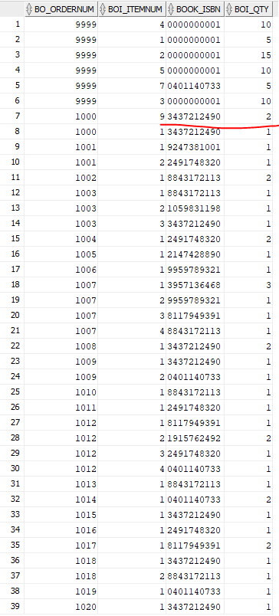

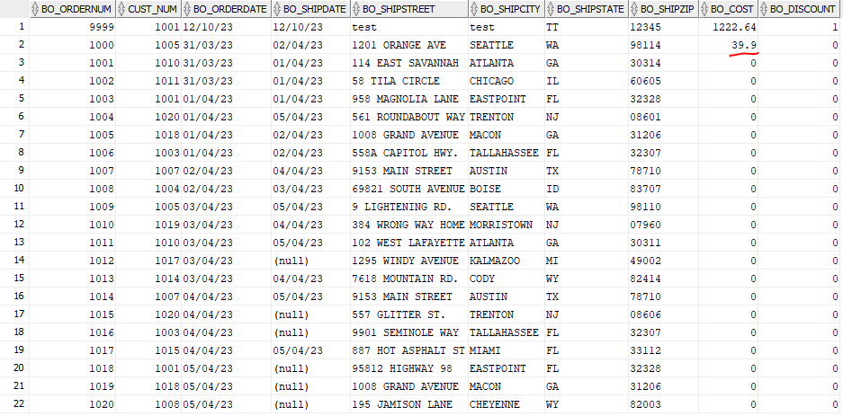
BOOKORDER:

Ninth trigger. BOOKORDERITEM has record; 1000, 10 with 50 NOT added. Not enough stock error message displayed.
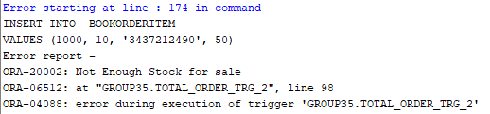

Question Bb)
Write a trigger that does not allow the book retail price to be updated when the increase (in retail price) is over 25%. Provide test data and corresponding results to confirm that the trigger works.

Code:
CREATE TRIGGER retail_control AFTER UPDATE OF book_retail
ON BOOK
FOR EACH ROW

DECLARE
retail_control_error EXCEPTION;

BEGIN
IF :new.book_retail/:old.book_retail > 1.25
THEN DBMS_OUTPUT.PUT_LINE ('Cannot raise retail price by more than 25%');
RAISE retail_control_error;
END IF;

EXCEPTION
WHEN retail_control_error
THEN raise_application_error(-20001, 'Cannot update');
END;
/

Test:
Negative Test:
UPDATE BOOK
SET book_retail = 400
WHERE book_isbn = 8117949391
;

Positive test:
UPDATE BOOK
SET book_retail = 10
WHERE book_isbn = 8117949391
;

Output:
Negative test:
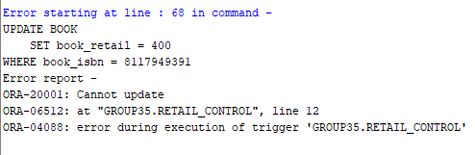

Positive test:
Before:
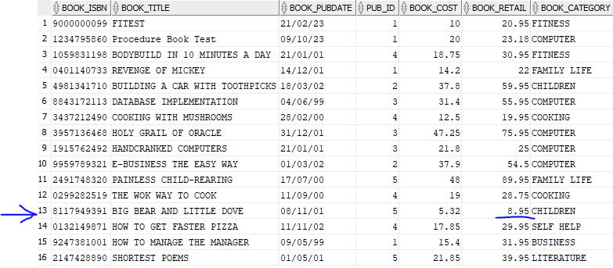
After:
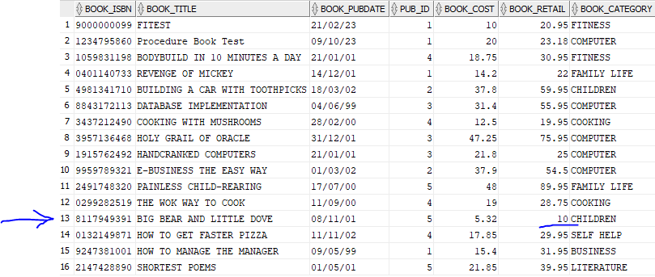

Question Bc)
Write a trigger that does not allow more than three author names to be associated with books under FITNESS category (e.g., if a Book is added, it should only allow up to 3 book authors to be recorded in BookAuthor table for ‘fitness’ category books). Provide the appropriate test data and results.

Code:
CREATE OR REPLACE TRIGGER trg_fitness_author_control
FOR INSERT ON BOOKAUTHOR
COMPOUND TRIGGER
TYPE type_isbns IS TABLE OF BOOK.book_isbn%TYPE;
v_isbns type_isbns := type_isbns();
v_book_category BOOK.book_category%TYPE;
v_count INTEGER;

AFTER EACH ROW IS
BEGIN
v_isbns.EXTEND;
v_isbns(v_isbns.COUNT) := :new.book_isbn;
END AFTER EACH ROW;

AFTER STATEMENT IS
BEGIN
FOR i IN 1 .. v_isbns.COUNT LOOP
SELECT B.book_category, a.cnt
INTO v_book_category, v_count
FROM BOOK B
CROSS APPLY
(
SELECT COUNT(*) as cnt
FROM BOOKAUTHOR BA
WHERE BA.book_isbn = B.book_isbn
) A
WHERE B.book_isbn = v_isbns(i);

IF v_book_category = 'FITNESS' AND v_count > 3 THEN
RAISE_APPLICATION_ERROR(-20001, 'Too many authors for fitness book ' || v_isbns(i));
END IF;
END LOOP;
END AFTER STATEMENT;
END trg_fitness_author_control;
/

Test:
--inserting test data into book, author and book author

INSERT INTO BOOK VALUES ('9000000099', 'FITEST', '21-FEB-23', 01, 10.00, 20.95, 'FITNESS', 1, 20.95);

INSERT INTO AUTHOR VALUES ('M200', 'Mycenae', 'Agamemnon');
INSERT INTO AUTHOR VALUES ('I200', 'Ithica', 'Odysseus');
INSERT INTO AUTHOR VALUES ('D200', 'Dardania', 'Aeneas');

INSERT INTO BOOKAUTHOR VALUES ('9000000099', 'M200');
INSERT INTO BOOKAUTHOR VALUES ('9000000099', 'I200');
INSERT INTO BOOKAUTHOR VALUES ('9000000099', 'D200');

--test by adding one more author to a fitness book with 3 already
INSERT INTO BOOKAUTHOR VALUES ('9000000099', 'P105');

Output:
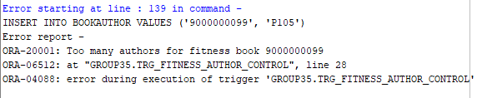

Question Bd)
Write a procedure to insert a new book record. The procedure should also automatically calculate the book retail value. This retail is calculated as 110.5% of the book cost price plus 4.5% of the average cost price of the existing books in the database. Provide rest of the attributes’ values as input parameters. Execute your procedure to insert at least one book record.

Code:
Note: This code assumes that publishers are added via a different business process because they require contact and phone details. There are no checks on the insert for duplicates as these are handled by constraints already existing on the book, book author and author tables.
CREATE OR REPLACE PROCEDURE PRC_INSERT_NEW_BOOK_RECORD2(
p_Book_ISBN IN BOOK.Book_ISBN%TYPE,
p_Book_Title IN BOOK.Book_Title%TYPE,
p_Book_PubDate IN BOOK.Book_PubDate%TYPE,
p_Pub_ID IN BOOK.Pub_ID%TYPE,
p_Book_Cost IN BOOK.Book_Cost%TYPE,
p_Book_Category IN BOOK.Book_Category%TYPE,
p_Author_ID IN AUTHOR.Author_id%TYPE,
p_Author_LName IN AUTHOR.Author_LName%TYPE,
p_Author_FName IN AUTHOR.Author_FName%TYPE
)

IS
v_Avg_Cost BOOK.Book_Cost%TYPE;
v_Book_Retail BOOK.Book_Retail%TYPE;
BEGIN
SELECT AVG(Book_Cost) INTO v_Avg_Cost FROM BOOK;
v_Book_Retail := ((1.105 * p_Book_Cost) + (0.045 * v_Avg_Cost));

INSERT INTO BOOK ( Book_ISBN, Book_Title, Book_PubDate, Pub_ID, Book_Cost, Book_Retail, Book_Category)
VALUES ( p_Book_ISBN, p_Book_Title, p_Book_PubDate, p_Pub_ID, p_Book_Cost, v_Book_Retail, p_Book_Category);
INSERT INTO AUTHOR (Author_id, Author_Lname, Author_Fname)
VALUES (p_Author_ID, p_Author_LName, p_Author_FName);
INSERT INTO BOOKAUTHOR (Book_isbn, Author_id)
VALUES (p_Book_ISBN, p_Author_ID);
COMMIT;
DBMS_OUTPUT.PUT_LINE('New book record inserted successfully.');

END;
/

Test:
-- Test insert of book record
EXECUTE PRC_INSERT_NEW_BOOK_RECORD2('0000000001', 'THE BROTHERS KARAMAZOV','09/10/23', 1, 20.00, 'FICTION',0,0, 'Z999', 'Fyodor', 'Dostoy');

Output:
Before:
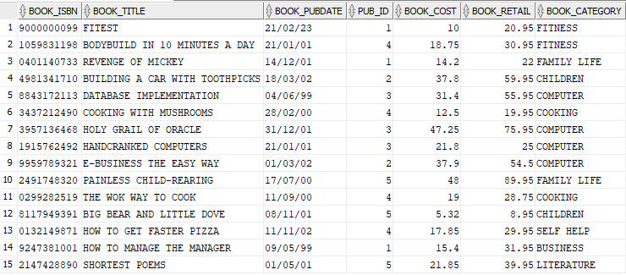
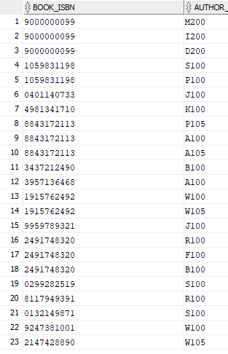
Book: Book Author:

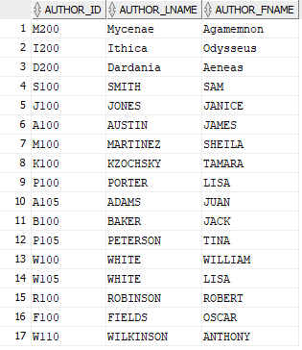
Author:

After:
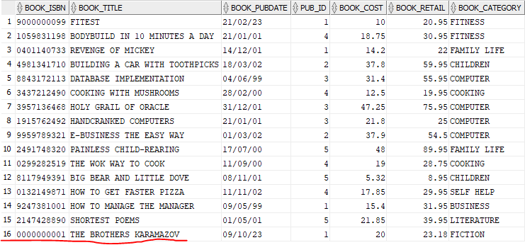
Book: Book Author:
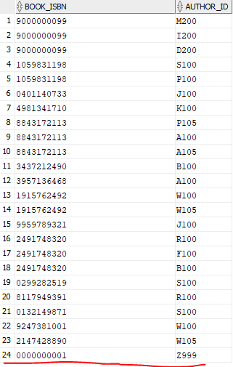

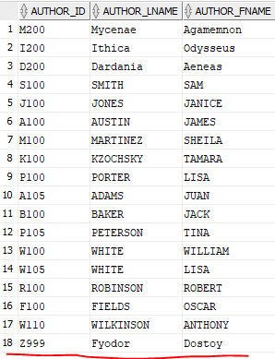
Author:

Inserting an existing record
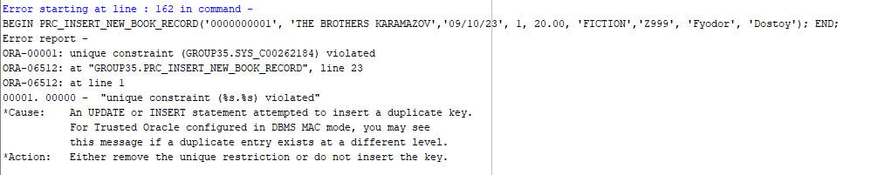

Question Be)
Use a cursor construct to list book authors for the ‘computer’ category books (along with their book title, cost, and retail). Present your work in a well readable report format (e.g., include headings, well-spaced expressions, some summary in the end).

Code:
DECLARE CURSOR computer_books_cursor IS

SELECT
B.Book_title,
B.Book_cost,
B.Book_retail,
LISTAGG( A.Author_Fname || ' ' || A.Author_LName, ', ') AS Author_Name
FROM BOOK B
JOIN BOOKAUTHOR BA ON B.Book_isbn = BA.book_isbn
JOIN AUTHOR A ON BA.Author_id = A.author_id
WHERE B.Book_Category = 'COMPUTER'
GROUP BY B.Book_title, B.Book_cost, B.Book_retail, B.book_category;

book_info computer_books_cursor%ROWTYPE;

BEGIN
DBMS_OUTPUT.PUT_LINE('-------------------------------------START OF REPORT---------------------------------------');
DBMS_OUTPUT.PUT_LINE('Book Title |Book Cost |Book Retail|Author Name |');
DBMS_OUTPUT.PUT_LINE('-------------------------------------------------------------------------------------------');

OPEN computer_books_cursor;
LOOP
FETCH computer_books_cursor INTO book_info;
IF computer_books_cursor%FOUND THEN
DBMS_OUTPUT.PUT_LINE(RPAD(book_info.Book_Title, 24) || ' | ' ||
TO_CHAR(book_info.Book_Cost, 9999.99) || ' | ' ||
TO_CHAR(book_info.Book_Retail, 9999.99) || ' | ' ||
RPAD(book_info.Author_Name, 40) || ' | ' );
ELSE
EXIT;
END IF;

END LOOP;
DBMS_OUTPUT.PUT_LINE('-------------------------------------------------------------------------------------------');
DBMS_OUTPUT.PUT_LINE('Total number of rows ' || computer_books_cursor%ROWCOUNT);
DBMS_OUTPUT.PUT_LINE('---------------------------------------END OF REPORT---------------------------------------');
IF computer_books_cursor%ISOPEN THEN
CLOSE computer_books_cursor;
END IF;

END;
/

Output:

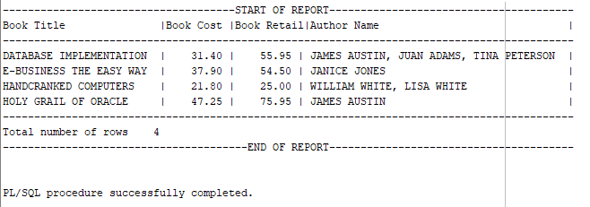

Question Bf)
Write a function to appropriately format money values (e.g., columns such as book cost, retail price uses a currency sign, commas if needed) when presented in some listing. Call this function in a SQL statement for displaying books’ costs and retail prices.

Code:
CREATE OR REPLACE FUNCTION FUNC_MONEY_FORMAT(v_amount NUMBER)
RETURN VARCHAR2 IS
v_formatted_amount VARCHAR2(100);
BEGIN
v_formatted_amount := TO_CHAR(v_amount, '$999,999,999.99');
RETURN v_formatted_amount;

DBMS_OUTPUT.PUT_LINE(FUNC_MONEY_FORMAT(1000000));
END;
/

Test:
--Test Code
SELECT
Book_Title AS "Book Title",
FUNC_MONEY_FORMAT(Book_Cost) AS "Book Cost",
FUNC_MONEY_FORMAT(Book_Retail) AS "Book Retail"
FROM
Book
;

Output:
Book Title | Book Cost | Book Retail
FITEST | $10.00 | $20.95
Procedure Book Test | $20.00 | $23.18
BODYBUILD IN 10 MINUTES A DAY | $18.75 | $30.95
REVENGE OF MICKEY | $14.20 | $22.00
BUILDING A CAR WITH TOOTHPICKS | $37.80 | $59.95
DATABASE IMPLEMENTATION | $31.40 | $55.95
COOKING WITH MUSHROOMS | $12.50 | $19.95
HOLY GRAIL OF ORACLE | $47.25 | $75.95
HANDCRANKED COMPUTERS | $21.80 | $25.00
E-BUSINESS THE EASY WAY | $37.90 | $54.50
PAINLESS CHILD-REARING | $48.00 | $89.95
THE WOK WAY TO COOK | $19.00 | $28.75
BIG BEAR AND LITTLE DOVE | $5.32 | $8.95
HOW TO GET FASTER PIZZA | $17.85 | $29.95
HOW TO MANAGE THE MANAGER | $15.40 | $31.95
SHORTEST POEMS | $21.85 | $39.95

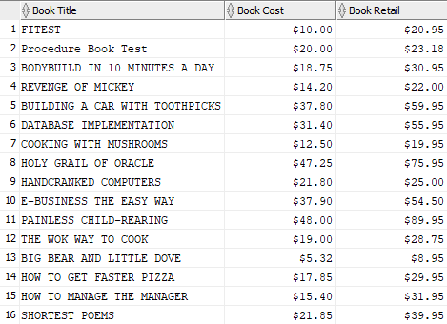

Section C (LINQ)

Question Ca)
List books with the retail price $25 or over.

Code:
var question1 =
from s in Books
where s.BookRetail > 25
select s;
question1.Dump();

Output:
BookIsbn | BookTitle | BookPubdate | PubID | BookCost | BookRetail | BookCategory | Bookorderitems | Bookauthors
1059831198 | BODYBUILD IN 10 MINUTES A DAY | 21/01/2001 0:00 | 4 | 18.75 | 30.95 | FITNESS | Bookorderitems | Bookauthors
4981341710 | BUILDING A CAR WITH TOOTHPICKS | 18/03/2002 0:00 | 2 | 37.8 | 59.95 | CHILDREN | Bookorderitems | Bookauthors
8843172113 | DATABASE IMPLEMENTATION | 4/06/1999 0:00 | 3 | 31.4 | 55.95 | COMPUTER | Bookorderitems | Bookauthors
3957136468 | HOLY GRAIL OF ORACLE | 31/12/2001 0:00 | 3 | 47.25 | 75.95 | COMPUTER | Bookorderitems | Bookauthors
9959789321 | E-BUSINESS THE EASY WAY | 1/03/2002 0:00 | 2 | 37.9 | 54.5 | COMPUTER | Bookorderitems | Bookauthors
2491748320 | PAINLESS CHILD-REARING | 17/07/2000 0:00 | 5 | 48 | 89.95 | FAMILY LIFE | Bookorderitems | Bookauthors
299282519 | THE WOK WAY TO COOK | 11/09/2000 0:00 | 4 | 19 | 28.75 | COOKING | Bookorderitems | Bookauthors
132149871 | HOW TO GET FASTER PIZZA | 11/11/2002 0:00 | 4 | 17.85 | 29.95 | SELF HELP | Bookorderitems | Bookauthors
9247381001 | HOW TO MANAGE THE MANAGER | 9/05/1999 0:00 | 1 | 15.4 | 31.95 | BUSINESS | Bookorderitems | Bookauthors
2147428890 | SHORTEST POEMS | 1/05/2001 0:00 | 5 | 21.85 | 39.95 | LITERATURE | Bookorderitems | Bookauthors
 |  |  |  | 295.2 | 497.85

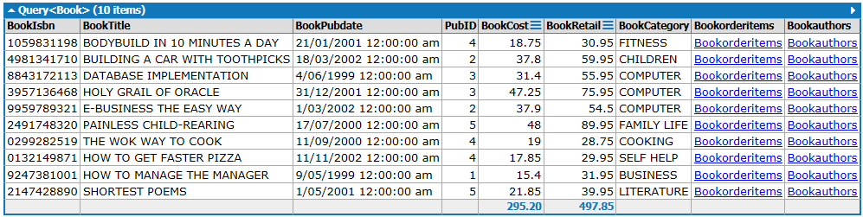

Question Cb)
List books that have the word “HOW” in the book title.

Code:
var question2 =
from s in Books
where s.BookTitle.Contains("HOW")
select s;
question2.Dump();

Output:
BookIsbn | BookTitle | BookPubdate | PubID | BookCost | BookRetail | BookCategory | Bookorderitems | Bookauthors
132149871 | HOW TO GET FASTER PIZZA | 11/11/2002 0:00 | 4 | 17.85 | 29.95 | SELF HELP | Bookorderitems | Bookauthors
9247381001 | HOW TO MANAGE THE MANAGER | 9/05/1999 0:00 | 1 | 15.4 | 31.95 | BUSINESS | Bookorderitems | Bookauthors
 |  |  |  | 33.25 | 61.9
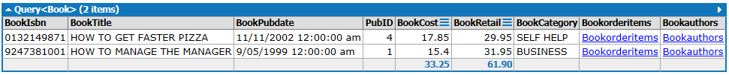

Question Cc)
List book categories, book titles and publisher names.

Code:
var question3 =
from s in Books
join p in Publishers
on s.PubID equals p.PubID
select new {s.BookTitle, s.BookCategory, p.PubName};
question3.Dump();

Output:
BookTitle | BookCategory | PubName
REVENGE OF MICKEY | FAMILY LIFE | PRINTING IS US
HOW TO MANAGE THE MANAGER | BUSINESS | PRINTING IS US
E-BUSINESS THE EASY WAY | COMPUTER | PUBLISH OUR WAY
BUILDING A CAR WITH TOOTHPICKS | CHILDREN | PUBLISH OUR WAY
HOLY GRAIL OF ORACLE | COMPUTER | AMERICAN PUBLISHING
DATABASE IMPLEMENTATION | COMPUTER | AMERICAN PUBLISHING
HANDCRANKED COMPUTERS | COMPUTER | AMERICAN PUBLISHING
COOKING WITH MUSHROOMS | COOKING | READING MATERIALS INC.
THE WOK WAY TO COOK | COOKING | READING MATERIALS INC.
HOW TO GET FASTER PIZZA | SELF HELP | READING MATERIALS INC.
BODYBUILD IN 10 MINUTES A DAY | FITNESS | READING MATERIALS INC.
PAINLESS CHILD-REARING | FAMILY LIFE | REED-N-RITE
BIG BEAR AND LITTLE DOVE | CHILDREN | REED-N-RITE
SHORTEST POEMS | LITERATURE | REED-N-RITE
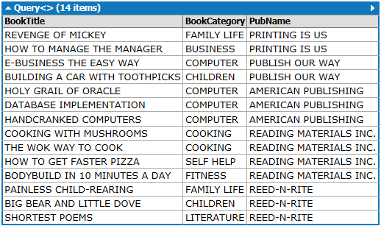

Question Cd)
Display total number of books by each publisher in the order of publisher ID.

Code:
var question4 =
from b in Books
join p in Publishers
on b.PubID equals p.PubID
group b by b.PubID into newgroup
orderby newgroup.Key
select new {
PublisherID = newgroup.Key,
TotalBooks = newgroup.Count()
} into g
join p in Publishers
on g.PublisherID equals p.PubID
select new{
PublisherID = g.PublisherID,
Publisher = p.PubName,
TotalBooks = g.TotalBooks};
question4.Dump();

Output:
PublisherID | Publisher | TotalBooks
1 | PRINTING IS US | 2
2 | PUBLISH OUR WAY | 2
3 | AMERICAN PUBLISHING | 3
4 | READING MATERIALS INC. | 4
5 | REED-N-RITE | 3
 |  | 14

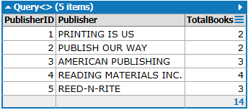

Question Ce)
Display the number of books under each category in the order of category.

Code:
var question5 =
from b in Books
group b by b.BookCategory into newgroup
orderby newgroup.Key
select new {
Category = newgroup.Key,
TotaBooks = newgroup.Count()
};
question5.Dump();

Output:
Category | TotalBooks
BUSINESS | 1
CHILDREN | 2
COMPUTER | 4
COOKING | 2
FAMILY LIFE | 2
FITNESS | 1
LITERATURE | 1
SELF HELP | 1
 | 14

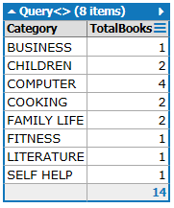

Section D (NOSQL / MONGODB)

Question Da)
Setting up the database of hobbits

Code:
//Insert the data

db.hobbits.insert({name: "Bilbo Baggins", dob: new Date(1992,2,13,7,47), loves:["horse riding","surfing"],weight: 45, gender: "m", cash: 3000});

db.hobbits.insert({name: "Rosie-Posie", dob: new Date(1961, 0, 24, 13, 0), loves: ["horse riding", "chess"], weight: 63, gender: "f", cash: 2250});

db.hobbits.insert({name: "Bingo Deepdelver", dob: new Date(1963, 1, 9, 22, 10), loves: ["scrabble", "basketball"], weight: 72, gender: "m", cash: 9000});

db.hobbits.insert({name: "Samwise Deepdelver", dob: new Date(1990, 7, 18, 18, 44), loves: ["cricket"],weight: 69, gender: "m", cash: 8000});

db.hobbits.insert({name: "Dora Toadfoot", dob: new Date(1985, 6, 4, 2, 1), loves:["cricket", "horse riding", "trekking"], weight:60, gender:"f", cash:6000});

db.hobbits.insert({name:"Kennoy Dippy", dob: new Date(1997, 6, 1, 10, 42), loves: ["chess", "rugby"],weight: 69, gender: "m", cash: 500});

db.hobbits.insert({name: "Rajaram Ghoda", dob: new Date(1985, 4, 3, 0, 57), loves: ["cricket", "boxing"],weight: 101, gender: "m", cash: 6500});

db.hobbits.insert({name: "Dolly Boffin", dob: new Date(1968, 9, 8, 14, 53), loves: ["cricket", "dancing"], weight: 52, gender: "f", cash: 6000});

db.hobbits.insert({name: "Ayna Shyna", dob: new Date(1958, 2, 7, 8, 30), loves: ["singing", "dancing"], weight: 73, gender: "f", cash: 5000});

db.hobbits.insert({name: "Lynx Todka", dob: new Date(1960, 2, 7, 8, 30), loves: ["singing", "dancing","horse riding"], weight: 93, gender: "m", cash: 5500});

db.hobbits.insert({name: "Aria Lyaria", dob: new Date(1964, 1, 9, 8, 40), loves: ["chess", "snooker","horse riding"], weight: 83, gender: "f", cash: 6500});

db.hobbits.insert({name: "Tane Shane", dob: new Date(1990, 3, 7, 9, 30), loves: ["singing", "dancing","horse riding"], weight: 98, gender: "m", cash: 5500});

db.hobbits.insert({name: "Tui Shui", dob: new Date(1975, 2, 8, 10, 30), loves: ["singing", "dancing","rugby"], weight: 75, gender: "f", cash: 7800});

db.hobbits.insert({name: "Tamati Shamati", dob: new Date(1991, 1, 7, 7, 30), loves: ["rugby", "soccer","go carting"], weight: 93, gender: "m", cash: 9500});

db.hobbits.insert({name: "Sheroo Beroo", dob: new Date(1999, 7, 7, 8, 25), loves: ["kite flying", "kabaadi","cricket", "stapu"], weight: 88, gender: "m", cash: 7500});

Output:
Finding one of the hobbits
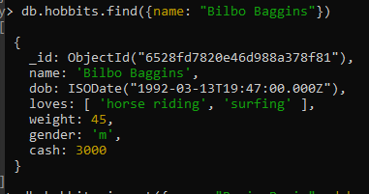

Question Db)
Generating a gender wise average weight report

Code:
//create the mapping output
var mapSectionD = function() {
emit(this.gender, { totalWeight: this.weight, count: 1 });
};

//calculate the average weight by sex
var reduceSectionD = function(key, values) {
var reduced = { totalWeight: 0, count: 0, avgWeight: 0 };

values.forEach(function(value) {
reduced.totalWeight += value.totalWeight;
reduced.count += value.count;
});

if (reduced.count > 0) {
reduced.avgWeight = reduced.totalWeight / reduced.count;
}

return reduced;
};

//specify the output
db.hobbits.mapReduce(
mapSectionD,
reduceSectionD,
{
out: "hobbits_SectionD"
}
);

//call the output
db.hobbits_SectionD.find();

Output:
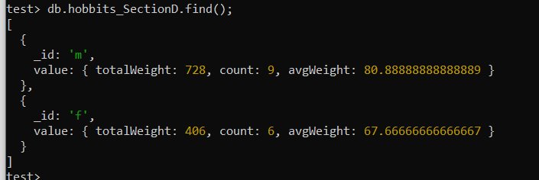

Question Dc)
Generating a gender wise average weight report using aggregation pipelines

Code:
//using aggregate pipelines
db.hobbits.aggregate(
[
{
$group:
{ _id:"$gender",
avgweight:{ $avg:"$weight"}
}
}
]
)

Output:
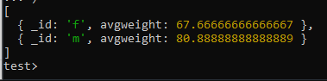

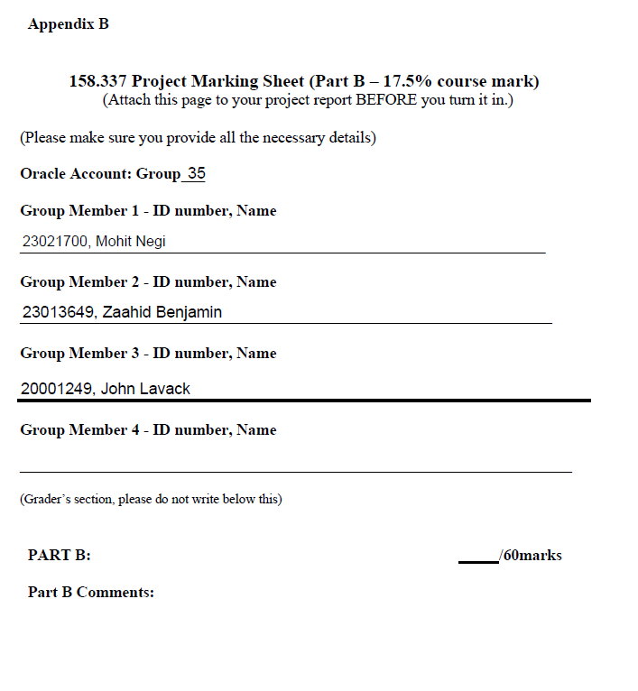
Appendix A: Marking Sheet:

